MACH4METAL

metalworking machinery
Transito 21,
6909 DA BABBERICH, Netherlands

Bank No : 66.52.13.883
IBAN : NL33 INGB 0665 2138 83
BIC : INGBNL2A

DMG Gildemeister CTX beta 1250 TC 4A

- Make : DMG MORI
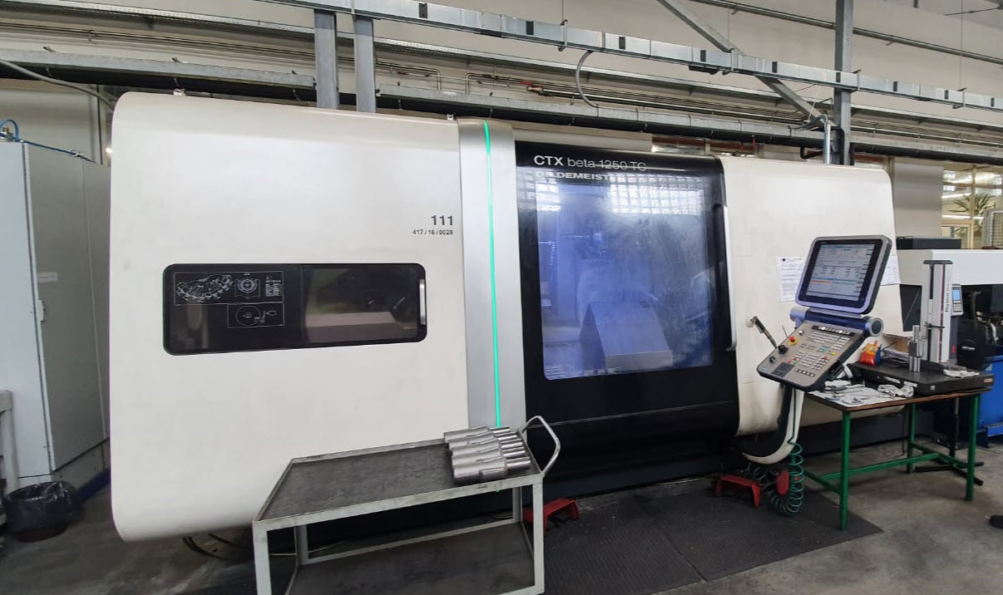
- Type : CTX beta 1250 TC
- Serial :
- Age : 2012 – 12.000 H

- Max. turning Ø : 700
- Machining Ø : 500
- Centre distance : 1.185

- Spindle bore : 67
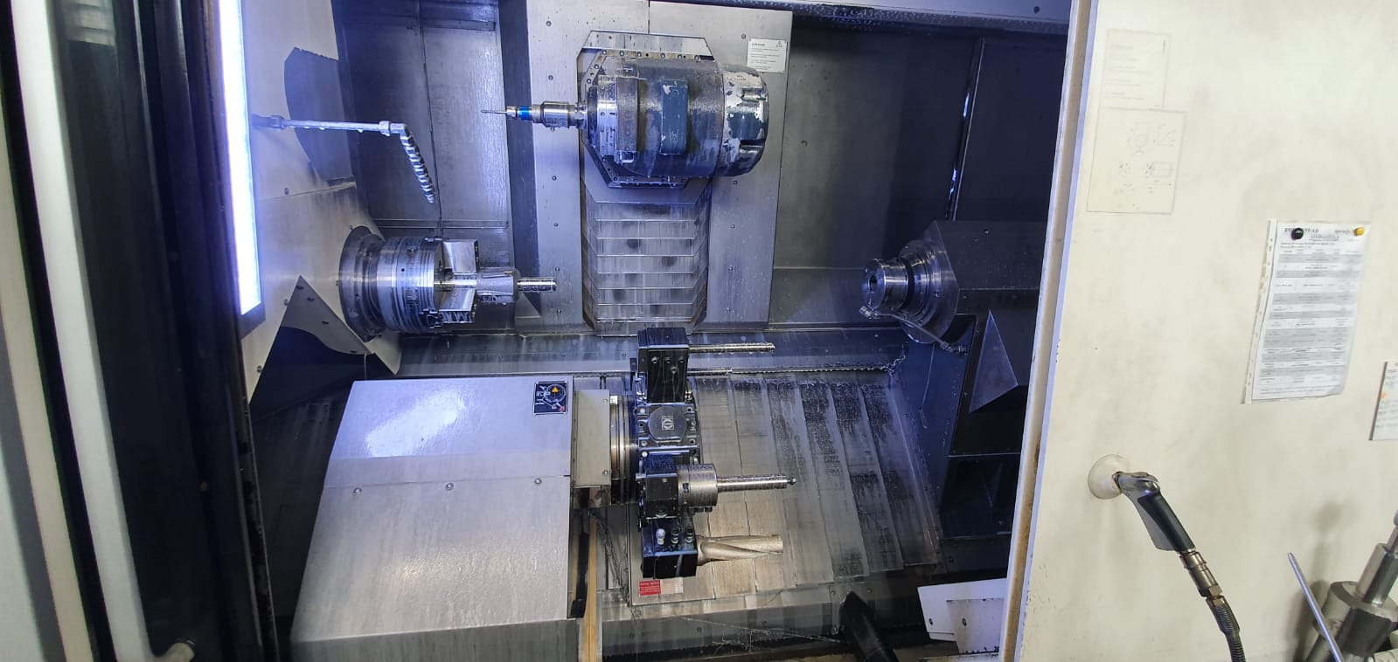
- Speeds ranges : 5.000
- Power kW : 32
- C Axis : 360.000

- Sub Spindle bore : 67
- Sub Speeds ranges : 5.000
- Power kW : 32
- C Axis : 360.000
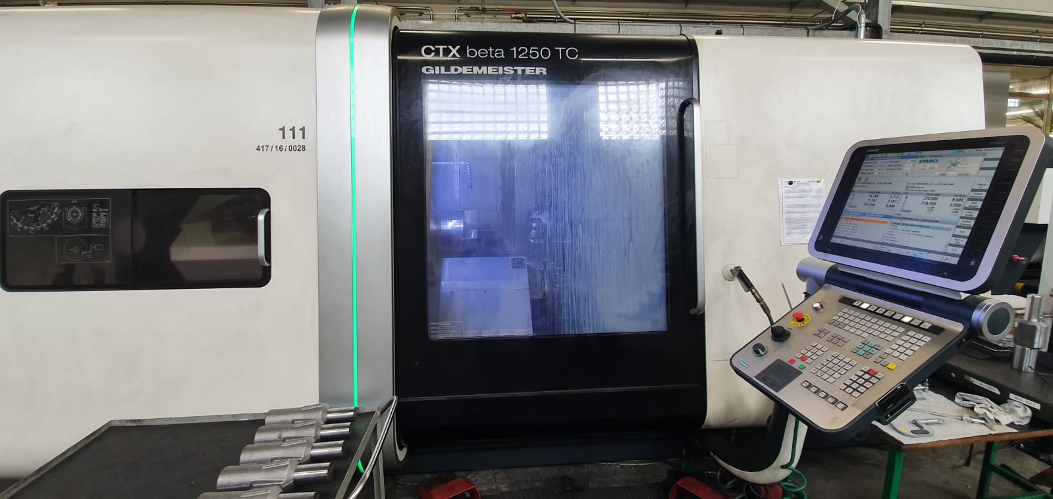

- X Travel : 490
- Y Travel : 100
- Z Travel : 1.200

- B Axis : Hsk 63
- Revolver : 24 positions
- Speed range : 12.000
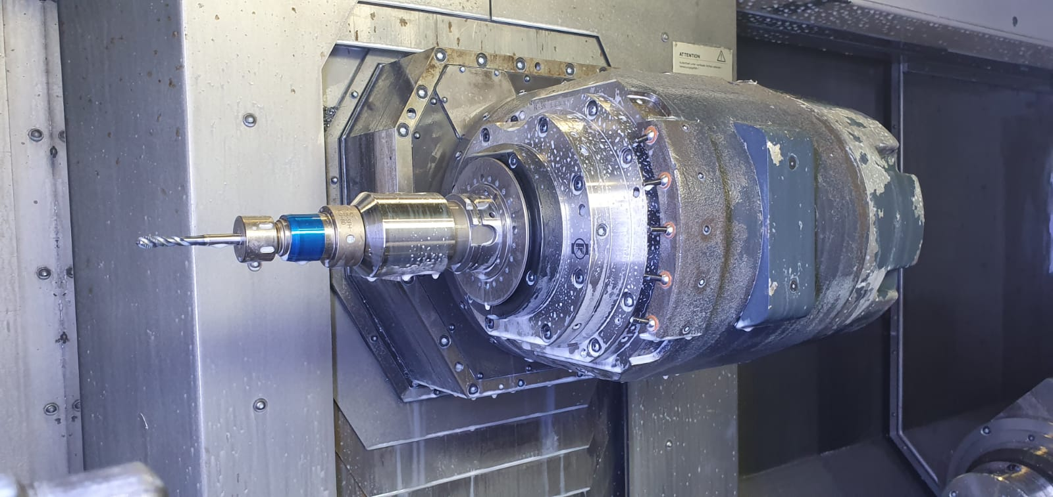
- Power : 22.5 kW

- Lower turret : 12 positions
- Speeds live tools : 4.000
- Power : 10 kW

- Control SIEMENS 840D
- Chip conveyor

- Dimensions:
- Length : 5.000 x 2.700 x 2.900 x 15 T
Please Note: The above information has been obtained to the best of our ability and belief from, and from the manufacturers where possible. It is given in good faith, but its accuracy can not be guaranteed. Accordingly, it will not form a representation or constitute contractual terms. We advise you to check any vital details !

